Becoming more flexible in the future – innovative routes into leak testing
ZELTWANGER PRESENTED SOMETHING REVOLUTIONARY IN QUALITY ASSURANCE AT EUROGUSS 2020

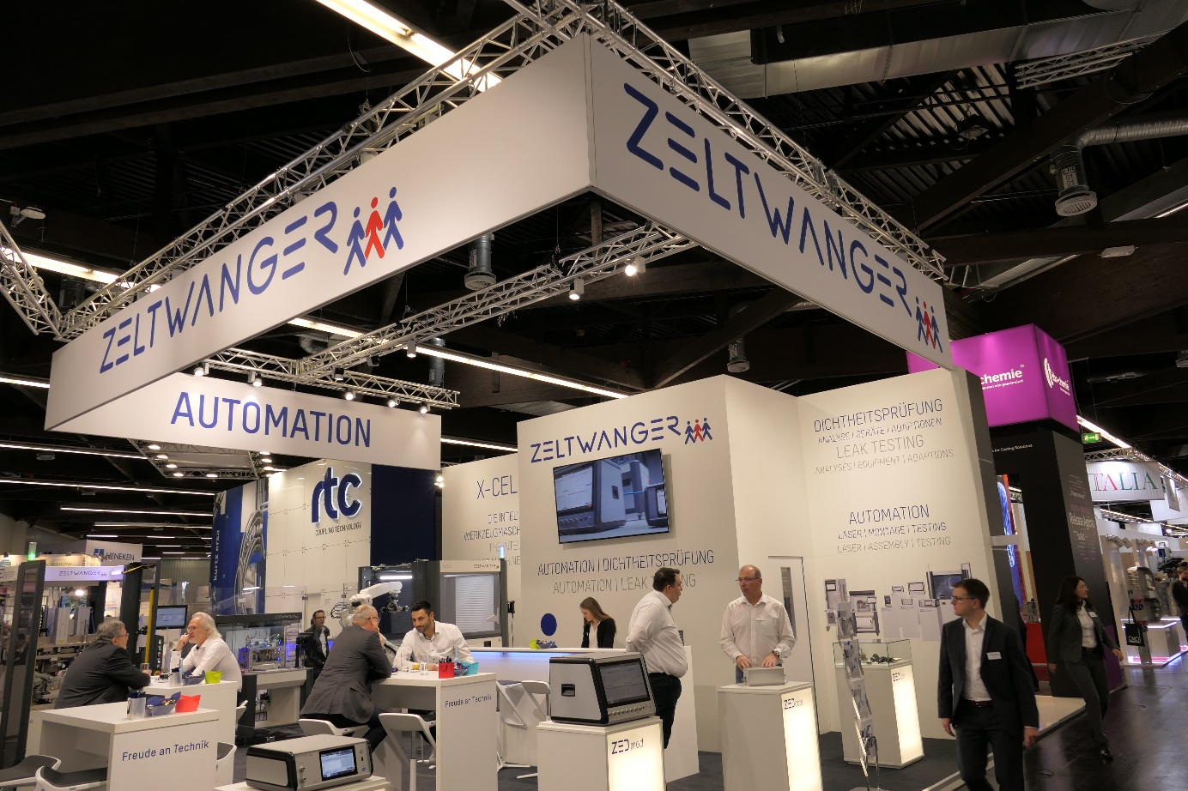

The pressure die-casting industry comes together every two years at the international trade fair EUROGUSS. This year, ZELTWANGER set some crucial benchmarks with its forward-looking development ZEDcore.

A leak testing revolution
(Tübingen, 02/03/2020) The ZEDcore is a measuring module according to a modular design principle. This is based on a ZELTWANGER concept that is one of a kind: What used to be permanently incorporated into test devices can now be used and put into operation independently in plug-and-play mode. This means that the measuring modules can be exchanged for different test procedures or a measuring module can be used in different devices.
“ZEDcore aroused a great deal of interest from the visitors at EUROGUSS,” explained Steffen Nabholz, Sales Manager at ZELTWANGER Dichtheits- und Funktionsprüfung. “This came as no surprise to us as the advantages are self-explanatory.” Although the concept seems rather modest at first, it has real potential. Shorter downtimes, low spare parts stocking, time and cost savings during calibration, lower follow-up costs – the modular structure offers significantly more flexibility and cost-effectiveness for the customer.

One family for all needs
ZEDcore is used across almost the entire ZED product family. Trade fair visitors were able to see this for themselves at the ZELTWANGER stand, from the compact test system ZEDeco for standard applications through to the highly complex, individually configurable sliding table system ZEDsystem. The machine in three different designs gave interested visitors a detailed insight into the cooperation between quality assurance and automation – something that ZELTWANGER is constantly further developing. Integration of additional processes, quick changeover, and loading via a robot – all this was demonstrated to the intrigued trade fair visitors.
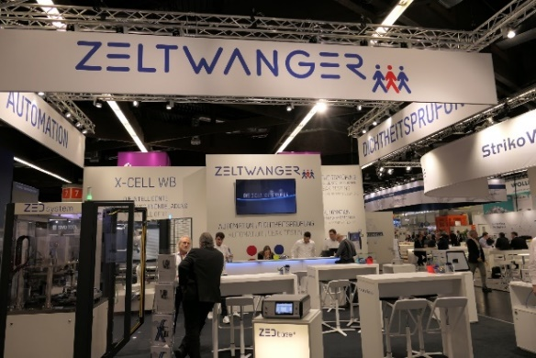
“It is very important to us to keep an eye on the challenges we can expect to face in the future,” said Nabholz. “This is why, for example, all our systems are already equipped with interfaces for predictive maintenance software.” Looking towards the future is what drives ZELTWANGER. The successful days spent at EUROGUSS resulted in lots of new contacts and the number of inquiries we received proved that the company is doing everything right.

___________________________
ZELTWANGER Holding GmbH
Technology and quality leader
The Zeltwanger Group has established a well-respected position in the market with its modular assembly and testing systems, which can be constructed individually and flexibly. The main focus is on manually linked “one-piece flow” line concepts and ergonomic single-position systems. In addition, fully automated part carrier and robot-based assembly systems meet customer-specific requirements. The range includes leak testing systems, modular assembly systems, pin assembly systems, and polishing systems for ceramic substrate. For use in the medical and biotechnological field, systems are created in accordance with European and American standards and the “Good Manufacturing Practice” guidelines.

ZELTWANGER Holding GmbH Press contact
Jopestr. 3 Steffen Kirchenbauer
72072 Tübingen, Germany Marketing & corporate communication
Telephone +49 70 71 36 63-301 +49 70 71 36 63-301
Fax +49 70 71 36 63-333 pr@zeltwanger.de
holding@zeltwanger.de

